Client Agreement project form

1) Select Agreement form

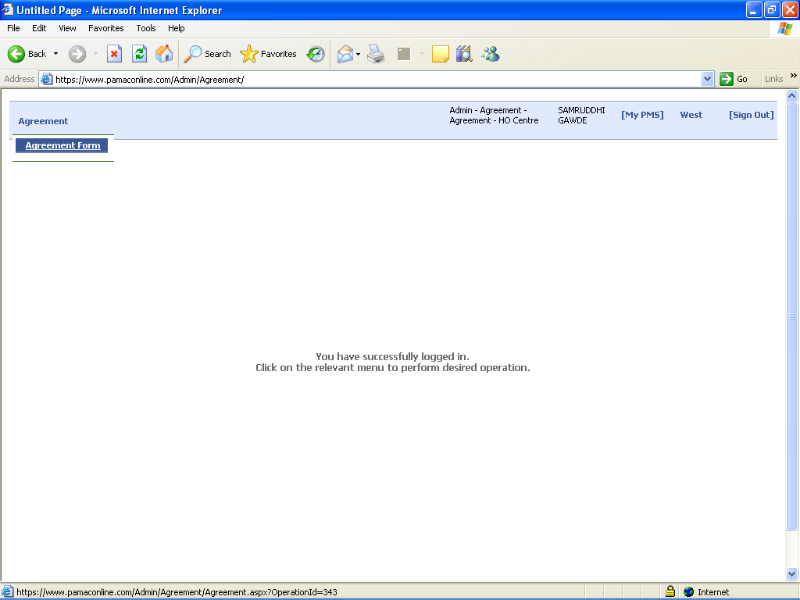

2) Select Agreement Category : 1)New Agreement
2) Annexure

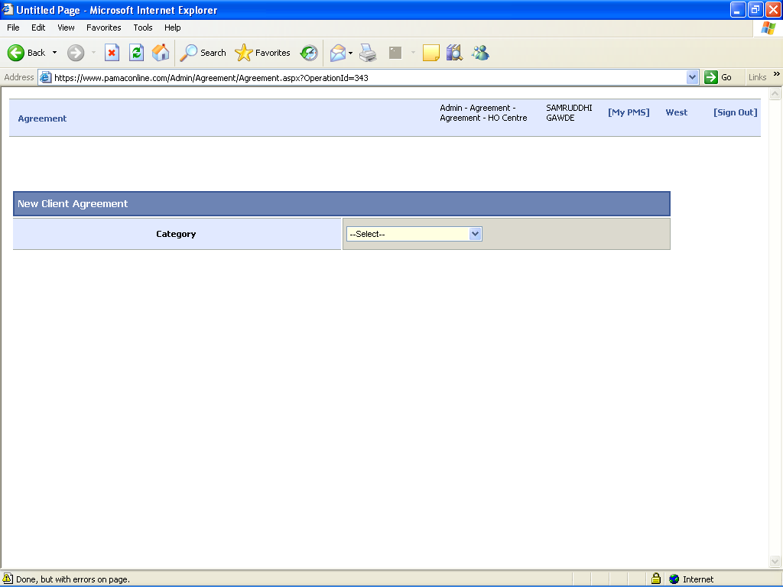

For new Client Agreement select “New Agreement”

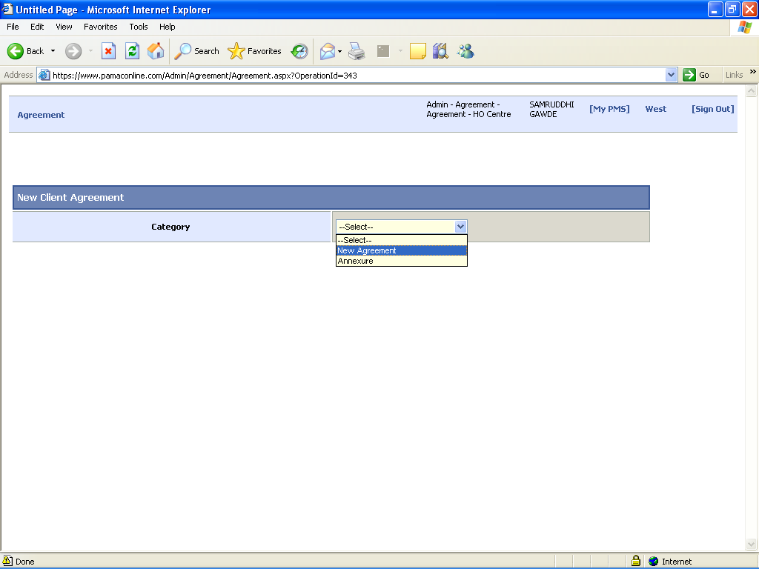

After the selection of “New Agreement” .Agreement form opened
- First select the client name as per the agreement and also fill up all details related that agreement like Date of Agreement, company name, contact person name …etc
- After inserting the all details click on the save option

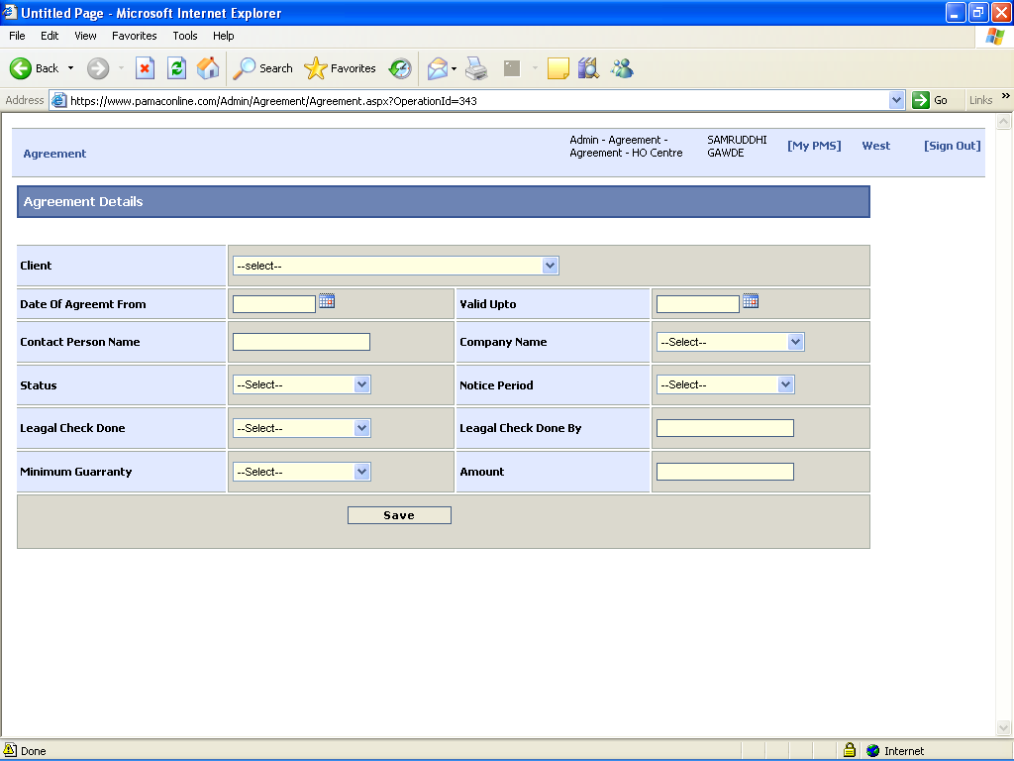

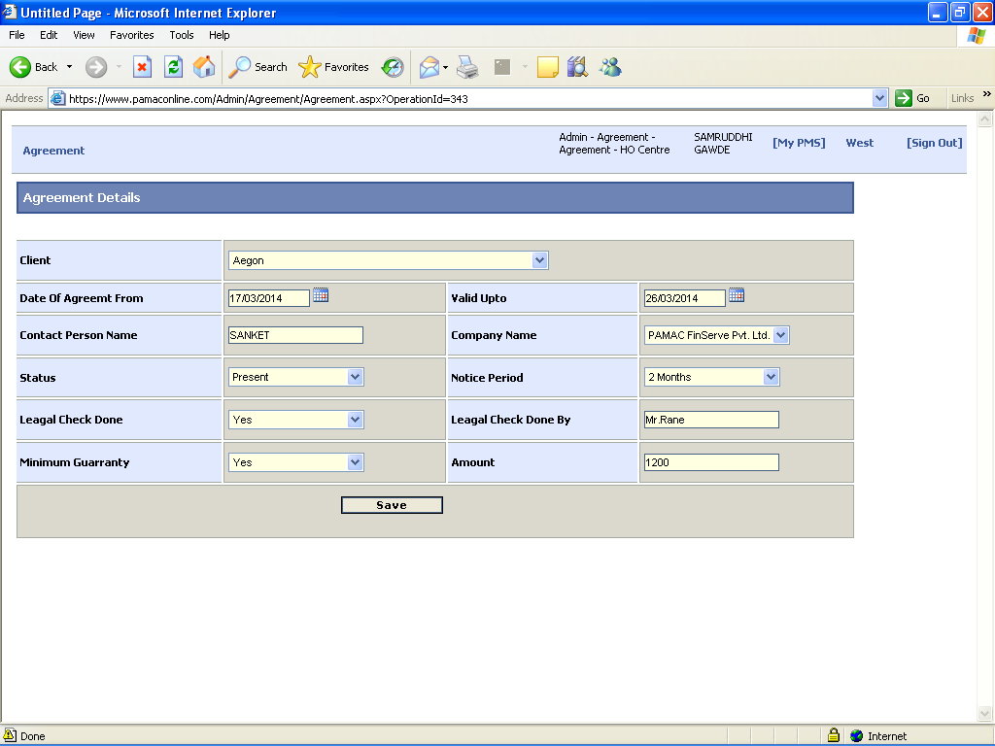

- After clicking save option then fill up all Rate details against that agreement as per the client on Rate Details form

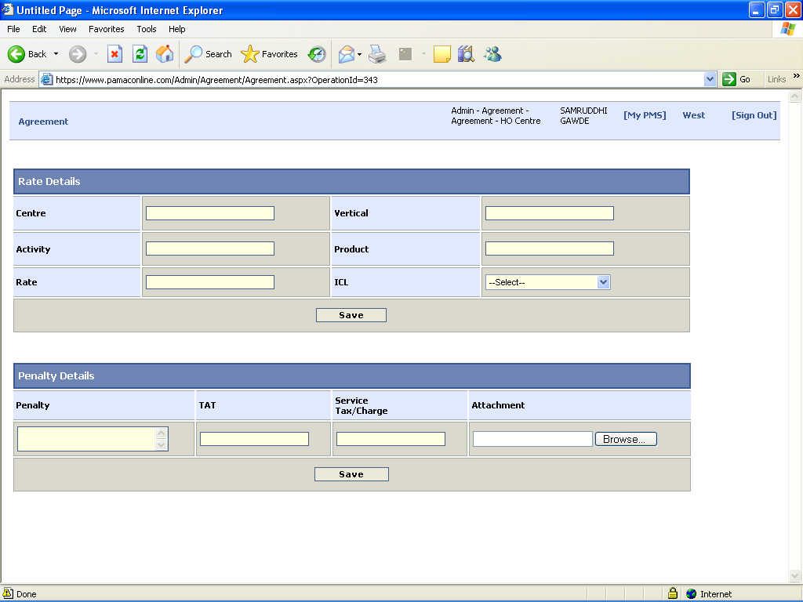

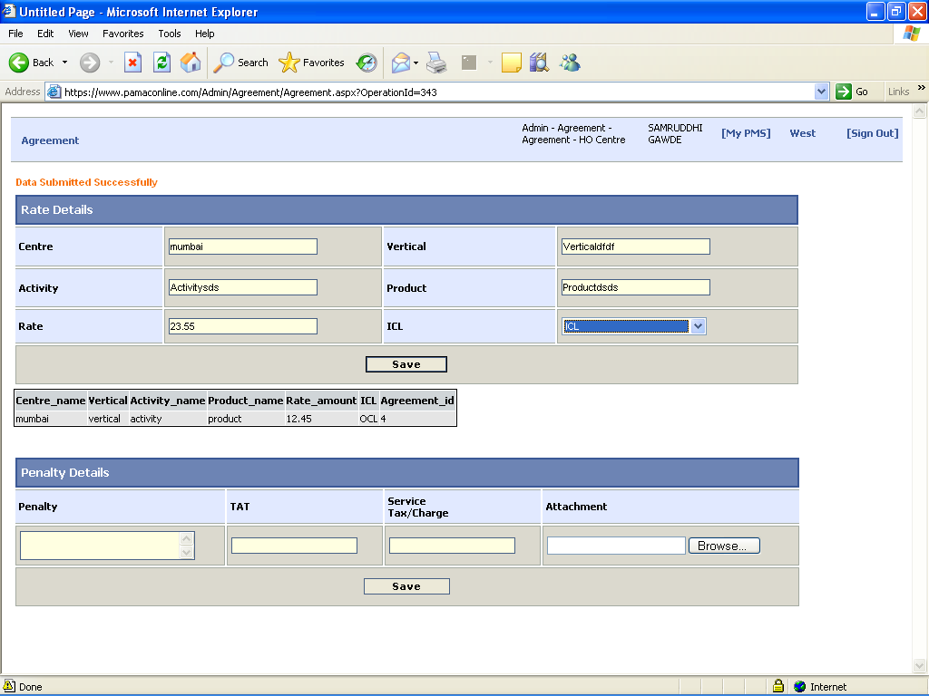

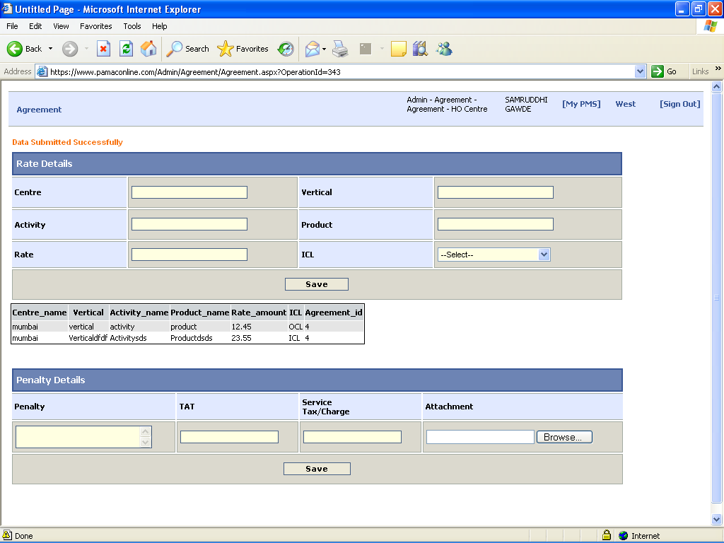

4) Also insert all penalty related Details against that client on penalty details form n save all data by using save option

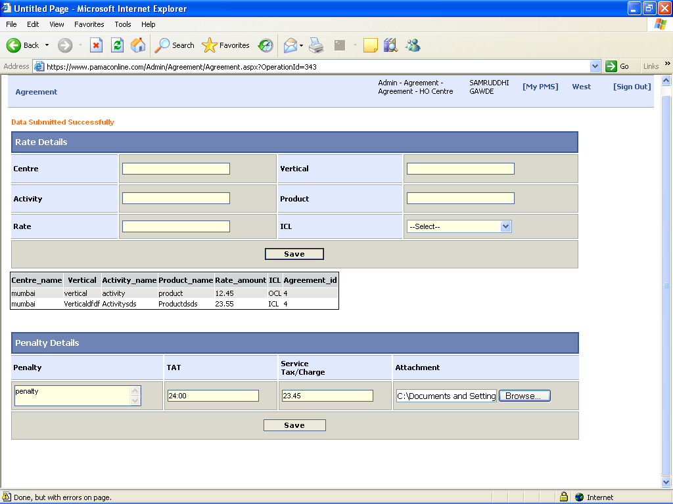

Select Annexure option if you don’t have new Agreement (rate details for old agreement) then annexure form is open.

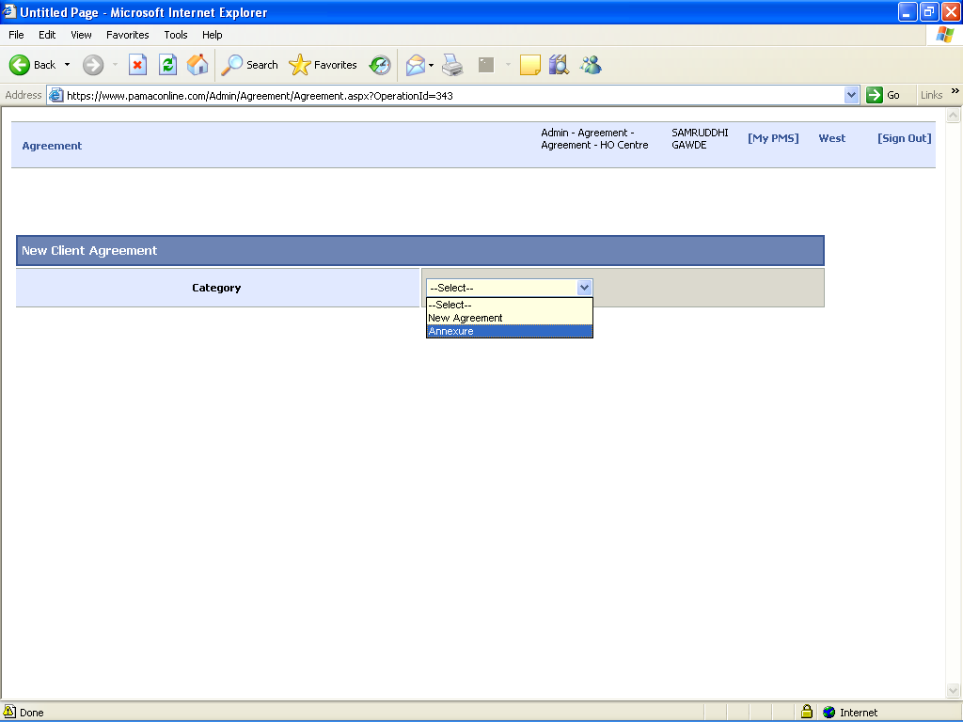

Select client name on annexure form and inserts all detail related rate of selected client agreement

